Sex discrimination in the workplace
Student’s Name
Institutional Affiliation
Date

Sex discrimination in the workplace
Introduction
Sexual discrimination is one of the significant issues affecting employees and employers in the workplace today. The victims of sexual discrimination and harassment are mainly women, although men also experience it. Sex discrimination is the differential treatment of people based on their sex. This paper identifies one of the issues surrounding sexual discrimination in one of the companies based in the UK. The text explores the case and its ruling stating the facts of the case. The case basically revolves around maternity leave and parental leave. The text takes the form of a memorandum to the CEO of the company, highlighting how he/she can avoid sex discrimination at his/her company.
Ali versus Capita Customer Management Limited
Capita Customer Management Limited is a private limited company based in the UK. This company was involved in a controversy with Mr. Ali. The issue raised in this case is about shared parental pay. The case is dubbed Ali v Capita Customer Management Limited. The Employment Appeal Tribunal (EAT) held that the failure to pay a father shared parental pay at the same rate as an employee on maternity leave is not sex discrimination. The court ruled that it was not discriminatory for an employer to pay male employees on shared parental leave less than the enhanced levels of pay, which are available to female counterparts when they are on maternity leave. An employee from Capita Customer Management limited, which operated policies where those who chose to take shared parental leave, were paid at statutory rates. Female employees on maternity leave, however, enjoyed a couple of weeks of pay before their entitlements dropped to legislative levels. Ali claimed that this disparity was, directly and indirectly, discriminatory on the basis of sex. The court of Appeal dismissed the claim.
The employee sought to be paid the same pay as a female employee would have been paid on maternity leave. Ali was only eligible for shared parental leave at the statutory rate of pay, claiming that it constituted direct sex discrimination. The claimant felt that it was unfair for mothers to be given 14 weeks of enhanced maternity pay while fathers received just two weeks of enhanced parental pay. Ali was initially victorious in his claim of direct sex discrimination, at ET, but the EAT overturned the ruling. The EAT ruled that there were reasons other than sex, mainly the health and wellbeing of the mother before and post-birth, that made women shouldn't be comparators. Therefore, the difference of two weeks was not discriminatory in any way.
A similar case was that of Hextall versus Constable of Leicestershire Police, where the EAT ruled that for indirect sexual discrimination, men on shared parental leave can compare themselves to women on maternity leave.
Applicable employment laws
Sexual equality/equal pay
The Equality Act 2010 provides a legal framework for protecting the rights of individuals as well as advance equality of opportunity for all (Stainback et al., 2011). The Act protects individuals from unfair treatment by employers and promotes an equal society. Schedule 7 of the Equality Act 2010 states that issues concerning paternity and maternity are excluded from any implied or express term of sex equality, which included enhanced maternity pay (Heilman & Eagly, 2008). Mr. Hextall claimed indirect discrimination. According to him, since he had less favorable terms and conditions than comparable female workers, the sex equality clause should operate to upgrade his terms. He contended that while on shared parental leave, he should be paid the same as a colleague on maternity leave. His argument failed because of an exception to the sex equality clause provisions for pregnant women who have given birth or breastfeeding mothers. This exception covers the enhanced maternity pay, which means there was no ground on which to bring an equal pay claim.
Direct sex discrimination
Since men on shared parental leave cannot compare themselves with women on maternity leave because their circumstances are different. Maternity leave is for the safety of the mother due to pregnancy and childbirth. Maternity leave aims at helping women to prepare for pregnancy, breastfeed, recuperate from the effects of pregnancy and childbirth. It also serves to bond the mother and the child after delivery.
On the other hand, shared parental leave is provided to enable parents to look after their children. As such, the right comparator for a man on shared parental leave is a woman who is also on shared parental leave. Thus, there is no case of direct sex discrimination for the case of Ali.

Indirect sex discrimination
A claim can either be indirect/direct discrimination or equal pay but cannot be both. This is the reason why the indirect discrimination claim did not proceed. Nevertheless, the court claimed that birthmothers were not subject to comparison because their circumstances were different from those of Mr. Hextall. Mr. Hextall could not establish any disadvantage for male employees when compared to women.
From the above two cases, the overarching question is whether it is discriminatory to pay men on shared parental leave less than women on maternity leave. When shared parental leave was introduced, there many concerns about sex discrimination (Stainback et al., 2011). Employers that enhance maternity were in a dilemma of whether or not to offer increased shared parental pay. Employers who do not do so risk a sex discrimination claim from men workers. The employers have to be prepared to justify their policy.
Sex discrimination at the workplace
Sex discrimination is one of the significant issues in many companies and workplaces. Sex or gender discrimination in employment involves treating someone differently or unfavorably because of their sex. It is the differential treatment of people based on their sex, whether they are male or female. This may occur when applying for a job or a current in the workplace. Women have been the primary victims of sexual discrimination, although it can as well be directed towards men. It is illegal to discriminate against anyone in the workplace because of their sex.
Sex discrimination can be categorized as either direct or indirect. Direct discrimination occurs when an employee is treated unfavorably because of their sex (Hegewisch, Deitch, & Murphy, 2011). Indirect sex disc, on the other hand, is when managers or employers hold assumptions about what kind of women are capable or incapable of doing. Sex discrimination takes the form of gender identity, sexual orientation, career, and parental status, marital status, pregnancy, and breastfeeding.
Some forms of sex discrimination include:

Glass ceiling
This is a promotional barrier that hinders women from ascending on the corporate ladder (Cotter et al., 2001). As a result, women occupy jobs which low in rank while men take the top rank jobs. This is a result of the belief that women may not be able to make sound decisions that are required in management. Despite their qualification, women are discriminated from being CEOs, managers and directors because of their sex.
Sex discrimination also occurs when women are not hired because the boss feels she will not fit into a traditionally male workplace. It also happens when women and men different rates of pay. Additionally, dividing up work tasks based on whether the staff is male or female constitutes gender discrimination. Sex discrimination also involves being called derogatory names because of your sex. Again, it includes unwelcome sexual advances or requests for sexual favors and other verbal or physical harassment (Hegewisch, Deitch, & Murphy, 2011).
Discrimination based on gender identity
Gender identity is where an individual of one sex identifies as a member of the opposite sex (Heilman & Eagly, 2008). This may be in the form of dressing, behavior, or hormonal therapy. Discrimination is rampant mainly to transgender people in employment. Transgender people experience significant levels of discrimination, such as missing out on employment opportunities and suffering from homophobic feelings from colleagues. The Lesbian, Gay, bisexual, and transgender (LGBT) people are the most affected in the workplace. Employers are directly and vicariously liable for their employee’s acts of discrimination or sexual harassment. Employers have the duty of eliminating sexual discrimination and victimization in the workplace.

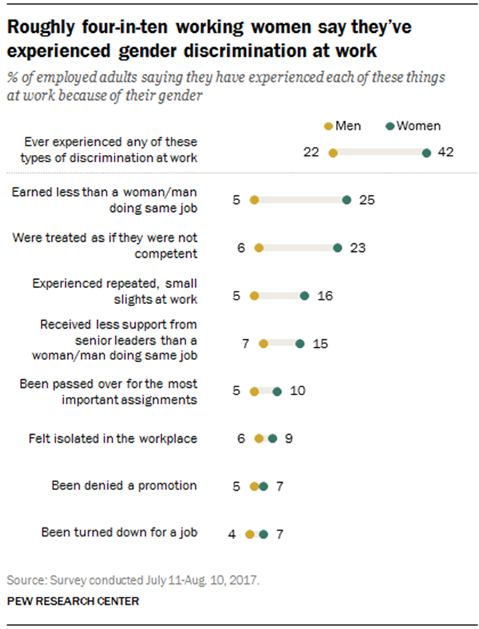
This chart from Pew Research Center shows how sex discrimination occurs at the workplace especially for women. The chart shows women have experienced more discrimination (42%) compared to men (22%). The chart also shows women leading in cases of job discrimination. For example, they are leading in denial for promotion, turned down for a job, treated as if they were incompetent among others.

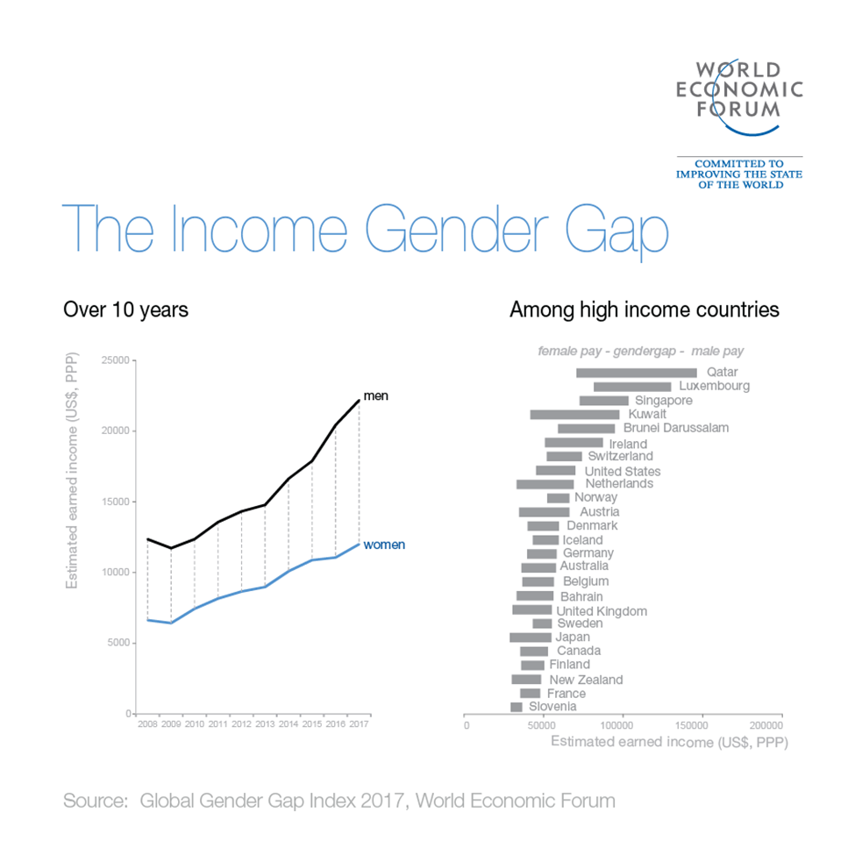This graph from World Economic Forum shows that men receive more income than women. Although the incomes are rising, men take the biggest share. Does this amount to sex discrimination? Yes, the income disparity shows men are favored in places of employment compared to women which shows there is sex discrimination.

How can the CEO prevent sexual discrimination?
Although I do not fault the ruling by Employment Appeal Tribunal (EAT), it is evident that sometimes it may be difficult and challenging to discern the activities that constitute sex discrimination. However, there are some basic things that the CEO or manager of a company can do to stop sex discrimination in his/her company. Employers have the duty of eliminating sexual discrimination and victimization in the workplace. They can do so by:
- Ensure that nondiscriminatory practices and requirements are used in hiring employees.
- Ensure the hiring of employees is based on merit, right qualifications, and no gender stereotyping.
- Set up workforce diversity programs to ensure a working environment that is comfortable for all employees.
- Ensure proper communication channels where employees who experience sex discrimination can report without retribution.
The CEO should ensure that every employee works in an environment free from sex discrimination. He or she should use any measures of combating this vice.

References
Cotter, D. A., Hermsen, J. M., Ovadia, S., & Vanneman, R. (2001). The glass ceiling effect. Social forces, 80(2), 655-681.
Hegewisch, A., Deitch, C. H., & Murphy, E. F. (2011). Ending sex and race discrimination in the workplace: Legal interventions that push the envelope. Institute for Women's Policy Research.
Heilman, M. E., & Eagly, A. H. (2008). Gender stereotypes are alive, well, and busy producing workplace discrimination. Industrial and Organizational Psychology, 1(4), 393-398.
Stainback, K., Ratliff, T. N., & Roscigno, V. J. (2011). The context of workplace sex discrimination: Sex composition, workplace culture, and relative power. Social Forces, 89(4), 1165-1188.

